**PROJECT 1**

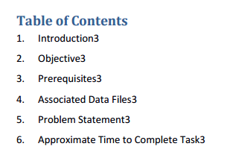

**dataset:**

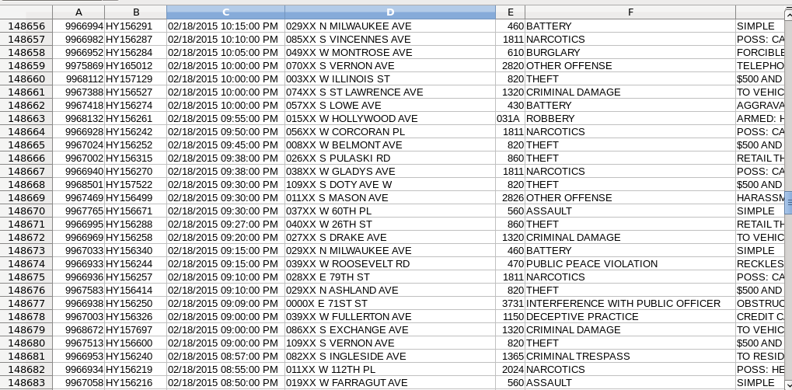

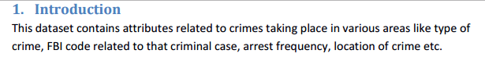



* **Driver class:**

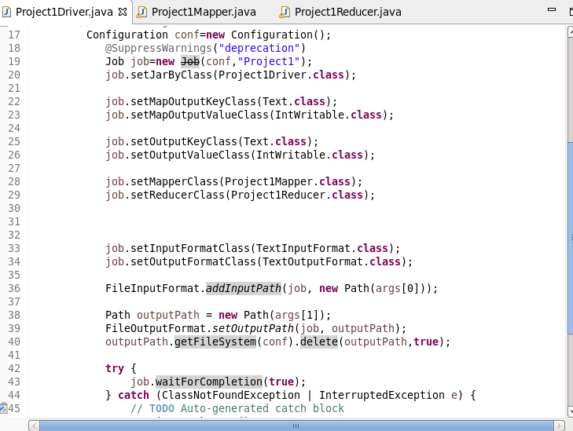

* **Mapper class:**

Sending fbi code as key and 1 as output

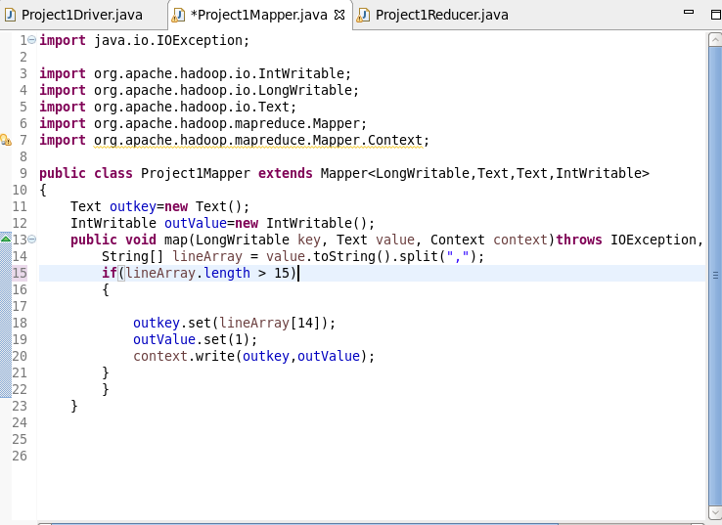

* **Reducer class:**

Counting no of cases for each fbi code

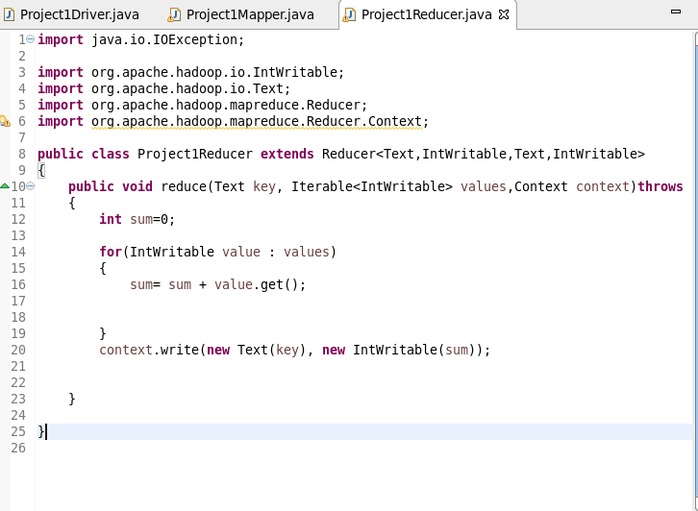

**Output:**

Copying file to hdfs

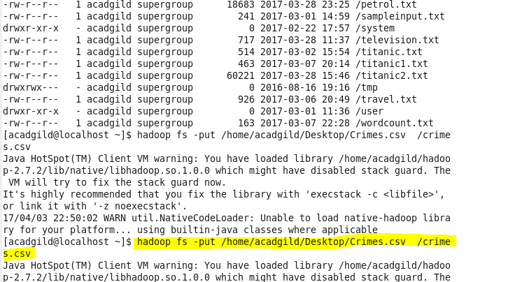

Running jar file:

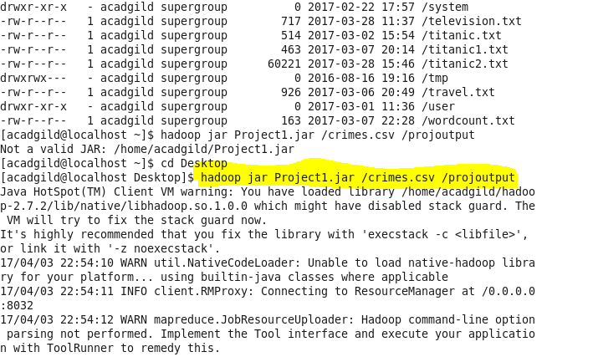

Output file:

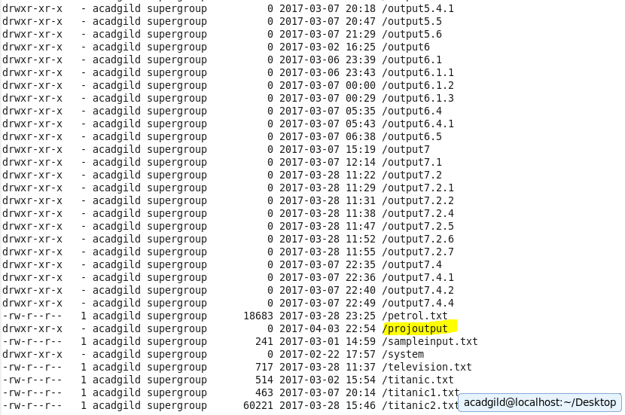

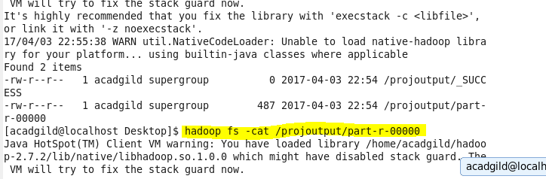

Final result

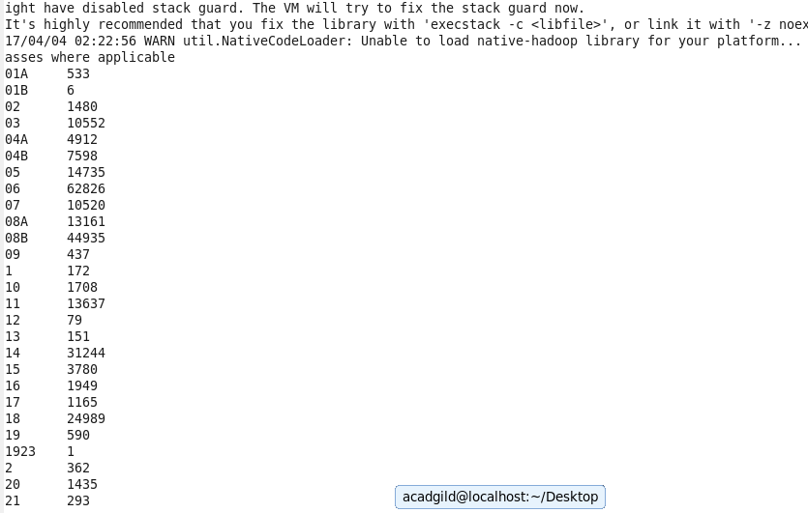



* **Driver class**

Set the configuration



* **Mapper class:**

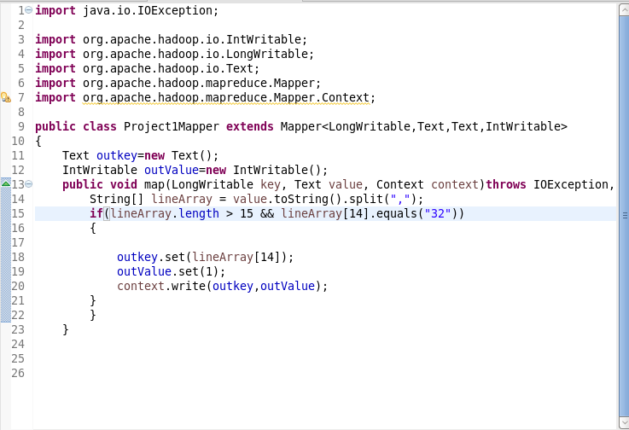

* **Reducer class:**



**Output:**

**Running jar file**

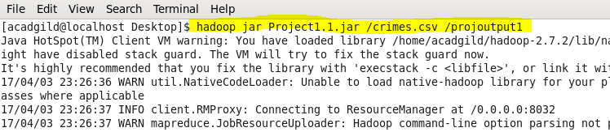

**Output directory created:**

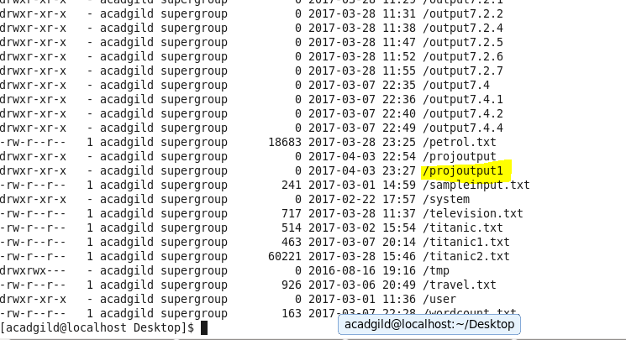

**Listing files in output directory**

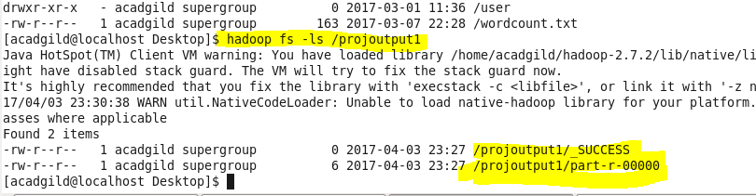

**Final output**

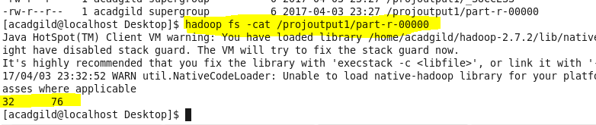



* **Driver class:**



* **Mapper class:**

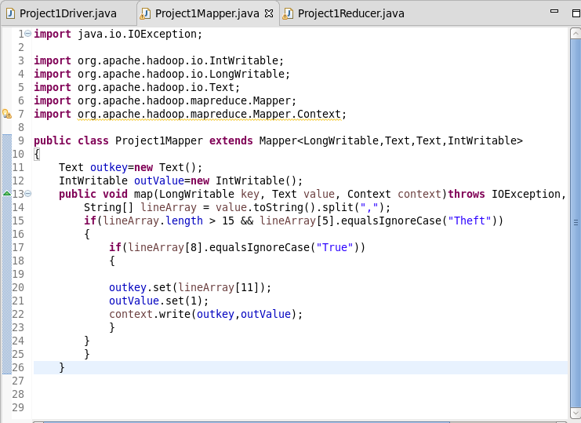

* **Reducer class:**



**Output:**

**Running jar file**

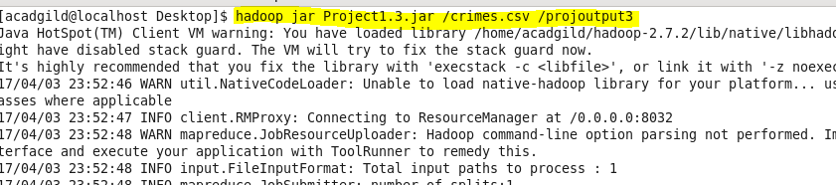

**Output file created**

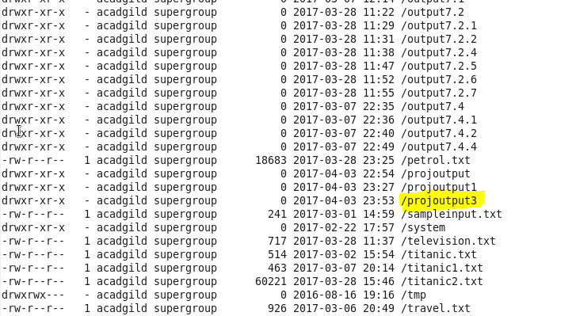

**Listing files in output directory**

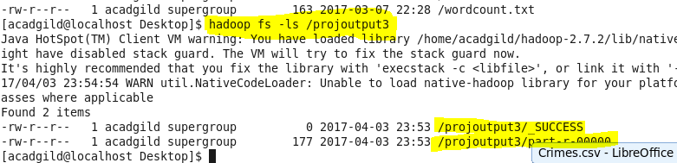

**Final output:**

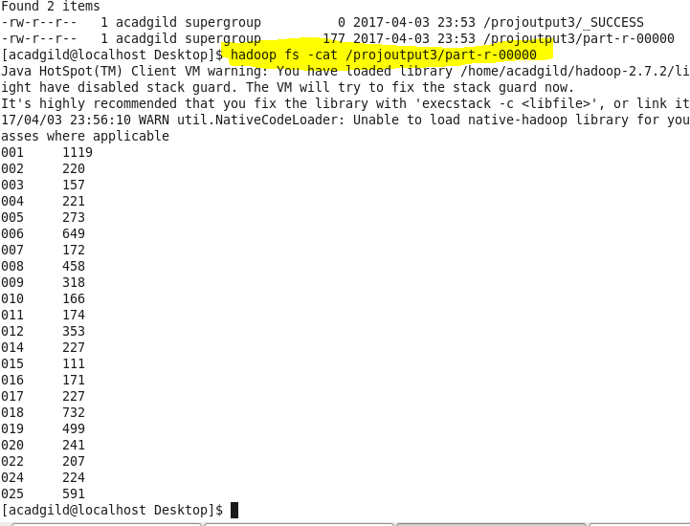



* **Driver class:**



* **Mapper class:**

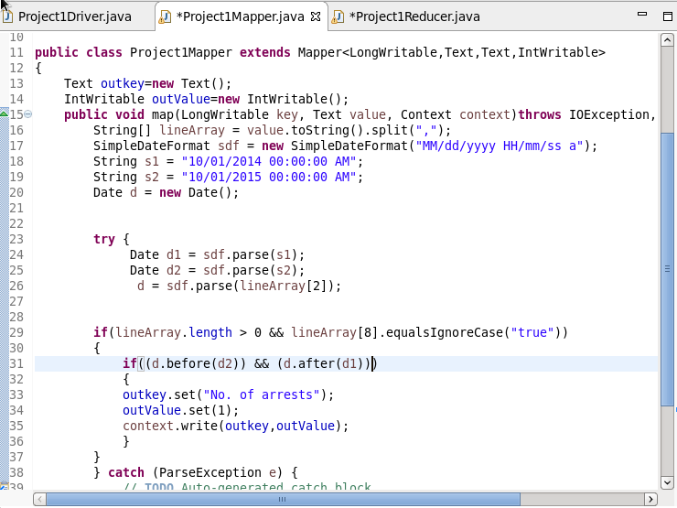

* **Reducer class:**



**Output:**

**Running jar file:**

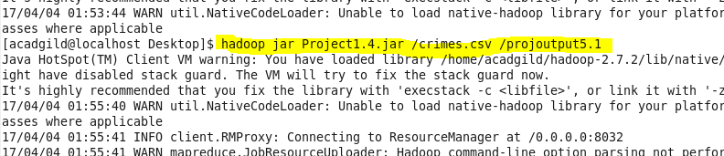

**Output file created :**

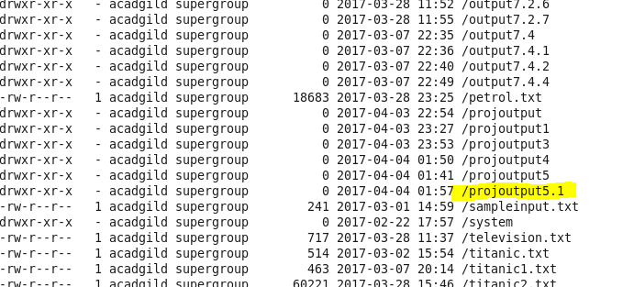

**Listing files of output directory**

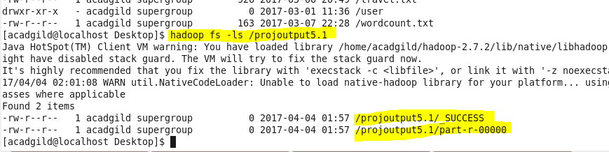

**Final Output:**

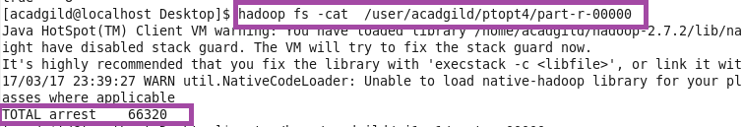

* **Write a pig program to calculate the number of cases investigated under each FBI code**

**Sample file(crimes.csv)**

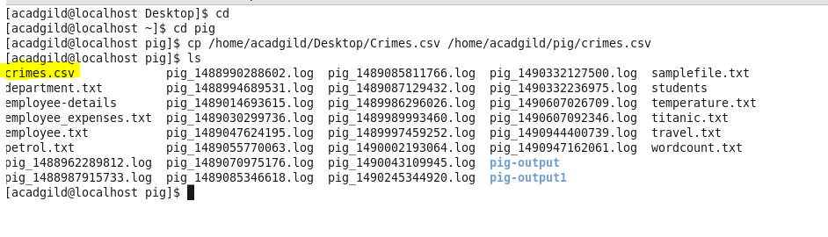

**Loading file:**

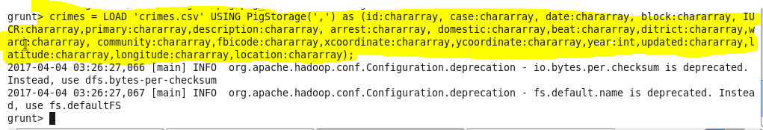

**Grouping by fbi code**

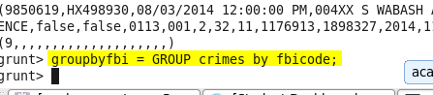

**Filtering out null values**

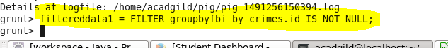

**Counting cases for each fbi code:**

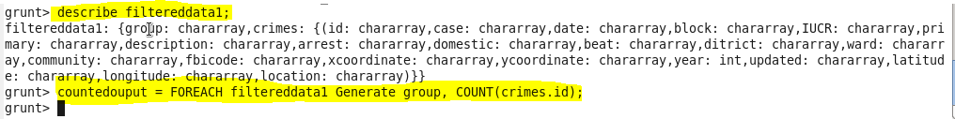

**Output:**

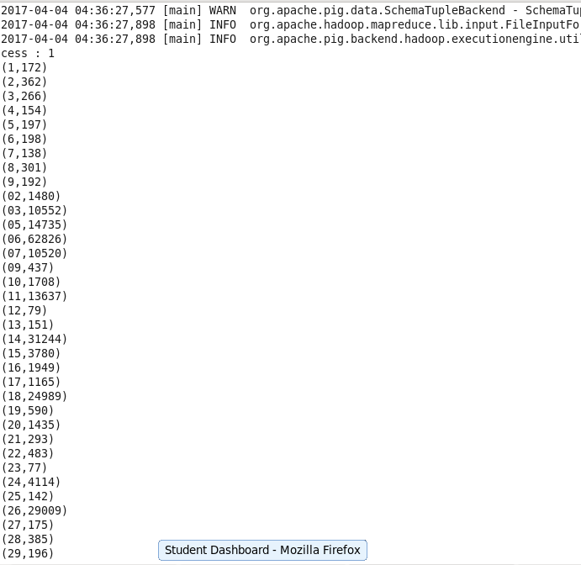

* **Write a pig program to calculate the number of cases investigated under FBI code 32**

**Filter data by fbicode = 32**

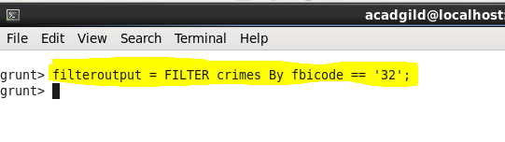

**Group data by fbicode and counting dataset**

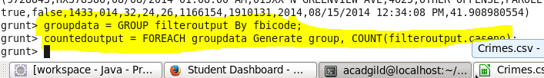

**Output:**

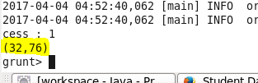

* **Write a pig program to calculate the number of arrests in theft district wise.**

**Filter data by arrest=true and crime primarytype = theft.**

**Group the result by district and generate count for each district;**

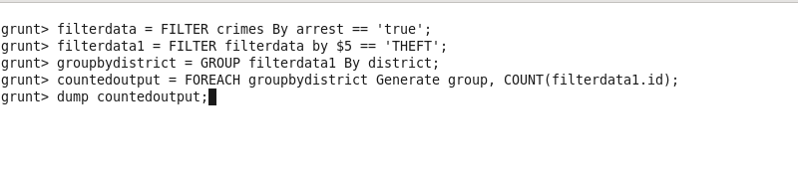

**Output:**

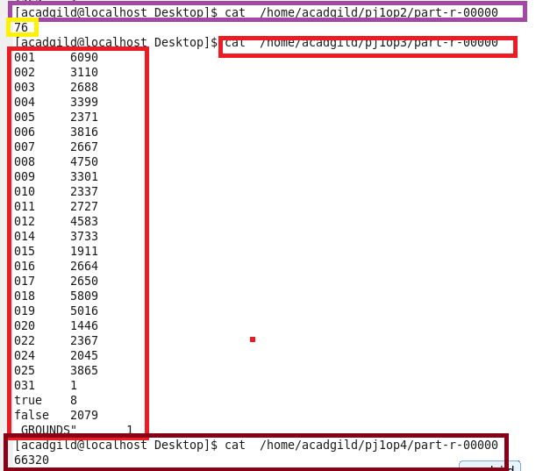

* **Write a pig program to calculate the number of arrests done between October 2014 and October 2015**

**Filter dataset where arrest has been done**

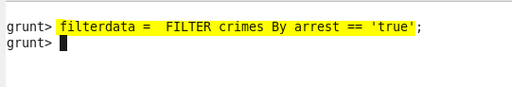

**Filtering data on basis of date of crime**

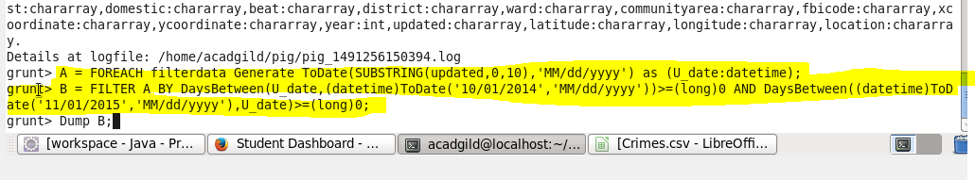

**Counting the cases between October 2014 and October 2015**

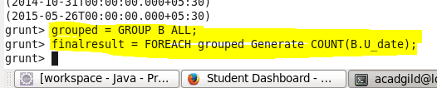

**Final output**

